**PRICE:** $15.00

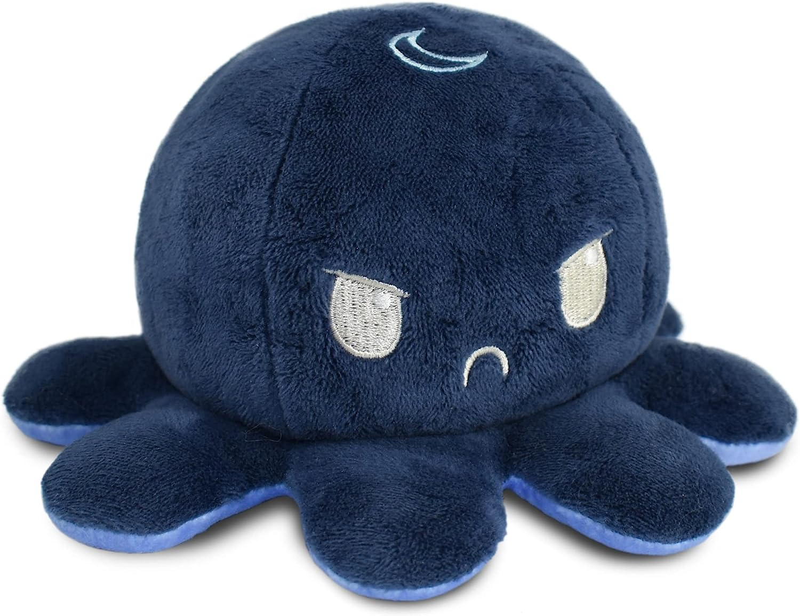

**ID:** S-03

**Color: Day/Night**

**Style:** Plushie + Turtle Plushie

* Product 1: This award-winning, #1 best-selling plushie is super soft, portable, and satisfying to flip!
* Product 1: Finally, an easy (and cuddly) tool for effective emotional communication. Relieve stress by letting the Reversible Plushie tell friends, family, or coworkers how you are feeling.
* Product 1: The perfect work-from-home tool to let friends and family know when not to bother you! Happy= come on in, and Angry= come back later!
* Product 1: Collect all the Reversible Plushie stuffed animals, including unicorns, narwhals, cats, dogs, pandas, turtles, and more, in tons of different colors!
* Product 2: This award-winning, #1 best-selling plushie is super soft, portable, and satisfying to flip!
* Product 2: Finally, an easy (and cuddly) tool for effective emotional communication. Relieve stress by letting the Reversible Plushie tell friends, family, or coworkers how you are feeling.
* Product 2: The perfect work-from-home tool to let friends and family know when not to bother you! Happy= come on in, and Angry= come back later!
* Product 2: Collect all the Reversible Plushie stuffed animals, including unicorns, narwhals, cats, dogs, pandas, turtles, and more, in tons of different colors!